Epsom & Ewell F.C.
13
v
Spelthorne Sports
Tuesday, 16th December 2014
For our League match this evening we welcome the players and officials of Spelthorne Sports, along with today's match officials and of course our own regular supporters.

Firstly, we apologise for the smaller programme tonight. Printing deadlines meant that we had to produce this before our recent trip to Badshot Lea and the Windsor programme will also be a more basic issue. We will catch up again for the next home match in mid-January.

Although this is our opponents first visit for a League match, they are familiar with the venue having edged us out on penalties after a goalless draw here in the Semi-Final of the Southern Combination Cup last April. Of course we gained a measure of revenge in September when winning 3-0 on our first ever visit to Spelthorne so you could say that this match is almost a decider!

We were last here two weeks ago when Camberley Town were defeated in the Surrey Senior Cup. It was a very tight game in which I felt we defended well, while the conditions ensured that it would be difficult to play too much football, which going into the game might have favoured our visitors, known as they are for their fairly direct style. However, we came through and it was a lot of fun hearing our name in the live draw on BBC Surrey, even if all we “earned” was a trip to Molesey in the next round!!

Following that match and a blank Saturday we travelled to Frimley Green for our Third Round League Cup tie. I’ll be honest, when the tie was drawn out, I thought we’d be visiting Spelthorne, but Frimley edged them out in extra time. However, that remains the last game Frimley won as we cruised to a 5-0 victory, although did have Matt Ferdinando sent off towards the end and he will be missing from our line up shortly.

Our next match is at Raynes Park Vale on Saturday 27th December and we are next here on 3rd January when we host Windsor. As this is our last home game of the year the Club Committee wish all supporters a Happy Christmas and New Year with the hope of some positive news regarding our new ground being the number one present of choice!

Thank you for following the Salts. The club, Glyn and the boys all value your support.

Rich

Cover photo this week by Richard Lambert

“Football Remembers” the First World War as Epsom and
Frimley Green pose for a joint photo on Tuesday

Cherry Red Records
Combined Counties League
Premier Division Table 2014/15
inc Tuesday 9th December 2014 | P | W | D | L | F | A | Pts | GD | H | A
Cove | 21 | 16 | 4 | 1 | 51 | 26 | 52 | +25 | 7/3 | 0-1
Ashford Town (Mx) | 20 | 14 | 2 | 4 | 49 | 19 | 44 | +30 | 2-4 | 10/1
Molesey | 19 | 14 | 0 | 5 | 56 | 19 | 42 | +37 | 1-3 | 28/2
Windsor | 20 | 13 | 3 | 4 | 49 | 24 | 42 | +25 | 3/1 | 11/4
Camberley Town | 18 | 12 | 3 | 3 | 36 | 12 | 39 | +24 | 7/2 | 0-1
Spelthorne Sports | 19 | 12 | 2 | 5 | 43 | 29 | 38 | +14 | 11/11 | 3-0
Hartley Wintney | 20 | 9 | 3 | 8 | 24 | 31 | 30 | -7 | 21/2 | 1-2
Colliers Wood United | 10 | 9 | 2 | 9 | 37 | 33 | 29 | +4 | 4/4 | 2-3
Bedfont Sports | 20 | 9 | 2 | 9 | 27 | 33 | 29 | -6 | 0-1 | 2-0
Epsom & Ewell | 20 | 8 | 2 | 10 | 35 | 30 | 26 | +5 | - | -
Farnham Town | 21 | 7 | 5 | 9 | 41 | 46 | 26 | -5 | 17/1 | 2-0
Mole Valley SCR | 22 | 7 | 5 | 10 | 41 | 51 | 26 | -10 | 1-0 | 5-2
Raynes Park Vale | 20 | 7 | 4 | 8 | 29 | 33 | 25 | -4 | 0-1 | 27/12
Badshot Lea | 21 | 7 | 4 | 10 | 36 | 42 | 25 | -6 | 21/3 | 13/12
Chertsey Town | 20 | 7 | 2 | 11 | 30 | 45 | 23 | -15 | 1-2 | 14/3
Knaphill | 19 | 6 | 3 | 10 | 23 | 47 | 21 | -24 | 18/4 | 4-1
Horley Town | 19 | 5 | 4 | 10 | 36 | 44 | 19 | -8 | 2-2 | 6/4
Frimley Green | 20 | 5 | 4 | 11 | 33 | 48 | 19 | -15 | 0-0 | 25/4
Westfield | 21 | 4 | 4 | 13 | 25 | 43 | 16 | -18 | 31/1 | 0-4
Guildford City | 20 | 4 | 2 | 14 | 31 | 59 | 14 | -28 | 4-1 | 28/3
Hanworth Villa | 18 | 3 | 2 | 13 | 22 | 40 | 11 | -18 | 13/1 | 5-2

Lucky Day? – 16th December
Played 10 - Won 7 Drawn 0 Lost 3 - F 25 A 18 - PPG 2.10 - Very Good
Club record against Spelthorne Sports
Played 2 - Won 1 Drawn 1 Lost 0 - F 3 A 0 - PPG 2.00 - Very Good
Last visit
Thursday 24th April 2014 - Drew 0-0 a.e.t. - Southern Combination Cup
Lost 2-4 on penalties

First Eleven Appearances - (max 27 inc Frimley Green)
Name | Debut | 2014/15 |  |  |  | Career Totals
 |  | App | Sub | Total | Goals | App | Sub | Total | Goals
BROWN Oshane* | 30/08/2014 | 2 | 0 | 2 | 0 | 2 | 0 | 2 | 0
CURRIE Sam | 04/08/2012 | 2 | 1 | 3 | 0 | 96 | 6 | 102 | 2
DEAN Dan | 02/08/2014 | 23 | 1 | 24 | 0 | 23 | 1 | 24 | 0
DEWAR Ali | 29/10/2011 | 5 | 2 | 7 | 3 | 55 | 31 | 86 | 10
DOUGLIN Karl* | 03/08/2013 | 1 | 0 | 1 | 1 | 41 | 3 | 44 | 14
DOWNS Carl* | 17/09/2011 | 4 | 1 | 5 | 0 | 94 | 13 | 107 | 2
EACOTT Michael | 02/08/2014 | 25 | 0 | 25 | 0 | 25 | 0 | 25 | 0
FARRELL Matt | 02/08/2014 | 25 | 1 | 26 | 2 | 25 | 1 | 26 | 2
FERDINANDO Matt | 20/09/2014 | 13 | 3 | 16 | 4 | 13 | 3 | 16 | 4
GAFFNEY Luke | 16/08/2014 | 10 | 1 | 11 | 0 | 10 | 1 | 11 | 0
HARPER Tommy* | 15/04/2014 | 1 | 0 | 1 | 0 | 2 | 1 | 3 | 0
HAYWARD Ben | 07/03/2007 | 5 | 0 | 5 | 0 | 241 | 28 | 269 | 18
HOADLEY Harry | 15/04/2014 | 6 | 1 | 7 | 0 | 7 | 1 | 8 | 0
HOUGH Kyle | 14/08/2007 | 23 | 1 | 24 | 12 | 277 | 13 | 290 | 149
JARMAN Mark | 08/08/2009 | 5 | 5 | 10 | 0 | 136 | 51 | 187 | 76
MARVELL Dale | 15/01/2000 | 11 | 5 | 16 | 5 | 261 | 45 | 306 | 85
MCGREGOR Alex | 08/08/2009 | 6 | 0 | 6 | 1 | 163 | 54 | 217 | 27
MCKAY Alex | 08/08/2009 | 3 | 3 | 6 | 0 | 68 | 25 | 93 | 7
MURPHY George | 28/03/2013 | 18 | 1 | 19 | 1 | 59 | 5 | 64 | 3
MUTIMA Lionel | 05/08/2014 | 4 | 2 | 6 | 0 | 4 | 2 | 6 | 0
NELMES Elliott* | 05/08/2014 | 2 | 0 | 2 | 0 | 2 | 0 | 2 | 0
PANAYI Anthony | 14/11/2010 | 19 | 1 | 20 | 0 | 146 | 15 | 161 | 4
ROBINSON Matt | 01/12/2012 | 10 | 1 | 11 | 0 | 11 | 4 | 15 | 1
ROBINSON Sam | 22/10/2011 | 16 | 1 | 17 | 6 | 40 | 4 | 44 | 11
ROWE Steve | 27/08/2011 | 3 | 0 | 3 | 0 | 8 | 1 | 9 | 0
SHAW Ollie | 20/09/2014 | 0 | 10 | 10 | 0 | 0 | 10 | 10 | 0
SMITH Taylor | 02/08/2014 | 13 | 2 | 15 | 7 | 13 | 2 | 15 | 7
TANTON Matt | 02/08/2014 | 16 | 4 | 20 | 1 | 16 | 4 | 20 | 1
TAYLOR James | 26/08/2013 | 20 | 1 | 21 | 2 | 37 | 7 | 44 | 3
VAN GELDER Julian* | 12/09/2006 | 0 | 1 | 1 | 0 | 0 | 2 | 2 | 0
WHITE Sean* | 02/08/2014 | 6 | 13 | 19 | 3 | 6 | 13 | 19 | 3
Own Goal |  |  |  |  | 1
* Player has left the club

Results and Fixtures
Surrey Senior Cup Second Round – Tuesday 2nd December
Badshot Lea | 2-1 | Kingstonian
Epsom & Ewell | 1-0 | Camberley Town
Knaphill | 0-3 | Colliers Wood United
Lingfield | 0-1 | Westfield
Molesey | 1-0+ | Egham Town
Tooting & Mitcham United | 2-2+ | Horley Town
Tooting & Mitcham United won 4-2 on penalties
Combined Counties League Cup Third Round – Tuesday 2nd December
Windsor | 8-1 | Ash United
Combined Counties League – Tuesday 2nd December
Bedfont Sports | 2-1 | Raynes Park Vale
Chertsey Town | 0-4 | Ashford Town (Mx)
F.A. Vase Third Round – Saturday 6th December
Colliers Wood United | 9-2 | Lingfield
Hanworth Villa | 0-2 | Erith & Belvedere
Horley Town | 1-3 | Greenwich Borough
Combined Counties League – Saturday 6th December
Ashford Town (Mx) | 0-1 | Molesey
Farnham Town | 4-1 | Knaphill
Frimley Green | 1-3 | Spelthorne Sports
Guildford City | 2-2 | Mole Valley SCR
Hartley Wintney | 1-2 | Raynes Park Vale
Westfield | 2-2 | Cove
Windsor | 0-0 | Bedfont Sports
Combined Counties League Cup Third Round – Tuesday 9th December
Camberley Town | 3-0 | Ashford Town (Mx)
Frimley Green | 0-5 | Epsom & Ewell
Combined Counties League – Tuesday 9th December
Bedfont Sports | 1-2 | Colliers Wood United
Horley Town | 2-1 | Hanworth Villa
Spelthorne Sports | 1-4 | Molesey
Combined Counties League Cup Second Round –Wednesday 10th December
Epsom Athletic | 0-5 | Banstead Athletic
Combined Counties League Cup Second Round – Saturday 13th December
Alton Town | V | Farnham Town
Results and Fixtures
Combined Counties League – Saturday 13th December
Badshot Lea | V | Epsom & Ewell
Bedfont Sports | V | Guildford City
Camberley Town | V | Chertsey Town
Cove | V | Ashford Town (Mx)
Knaphill | V | Colliers Wood United
Mole Valley SCR | V | Hanworth Villa
Molesey | V | Horley Town
Raynes Park Vale | V | Windsor
Spelthorne Sports | V | Hartley Wintney
Westfield | V | Frimley Green
Combined Counties League Cup Third Round – Tuesday 16th December
Badshot Lea | V | Guildford City
Westfield | V | Cove
Combined Counties League – Tuesday 16th December
Epsom & Ewell | V | Spelthorne Sports
Mole Valley SCR | V | Bedfont Sports
Combined Counties League Cup Third Round – Wednesday 17th December
Colliers Wood United | V | Horley Town
Combined Counties League – Saturday 20th December
Ashford Town (Mx) | V | Raynes Park Vale
Chertsey Town | V | Hartley Wintney
Colliers Wood United | V | Cove
Farnham Town | V | Camberley Town
Frimley Green | V | Horley Town
Guildford City | V | Knaphill
Hanworth Villa | V | Westfield
Windsor | V | Molesey
Combined Counties League – Saturday 27th December
Ashford Town (Mx) | V | Spelthorne Sports
Camberley Town | V | Frimley Green
Cove | V | Farnham Town
Hanworth Villa | V | Bedfont Sports
Hartley Wintney | V | Badshot Lea
Knaphill | V | Westfield
Molesey | V | Chertsey Town
Raynes Park Vale | V | Epsom & Ewell
Windsor | V | Guildford City

From the back of the stand
Epsom & Ewell 1-0 Camberley Town
Surrey Senior Cup - Second Round - Tuesday 2nd December 2014
Report by George Holland

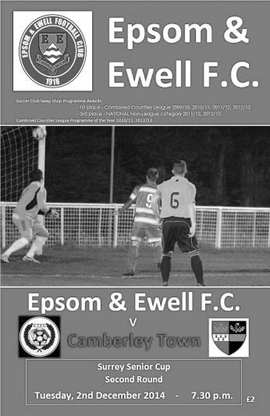
The Salts Kroon into the next round of the Surrey Senior Cup.

32 spectators, including Horsham YMCA Manager Pete Buckland, braved the cold, biting wind to see this hard fought narrow win. Epsom had the advantage of playing with the wind in the 2nd half. Anthony Panayi made his 160th appearance for us, and Sam Currie made a welcome return to the squad after his bad injury.

The first seven minutes saw Camberley dominate the play with several attacks. One of their shots hit the bar, before Eacott gathered the ball. He then fumbled another shot, with the ball being cleared. Epsom responded on 10 minutes when Kyle Hough fed Sam Robinson, whose cross was caught by their keeper. Three minutes later Matt Robinson's low shot was spilled by their keeper, and a defender cleared.

However, we scored in the 19th minute. A free kick out on the right edge of the area rebounded off the wall to McGregor. He strode forward and his low left footed drive went through the crowded area and into the far corner, giving the keeper no chance.

Steve Rowe strode forward with ambition on 23 minutes, but his wayward shot did not match the run. He cleared off the line on 39 minutes when Eacott fumbled a long Camberley throw in. Eacott was then a happy spectator when a curling shot spun past his far post. Both sides kept up the pressure right up to half time which saw the Salts go in 1-0 up.

Rowe cleared off his line again on 50 minutes, the Salts responding with efforts that came to naught. On 65 minutes a Camberley long throw saw an overhead kick, with the ball safely gathered by Eacott.

The game was beginning to stretch with both teams counter attacking. And on 78 minutes a cross shot from Matt Robinson clipped the top of the bar and went out for a goal kick. On 84 minutes a poor clearance from their keeper fell to Sam Robinson and Hough to combine to produce a header off the line, and Dan Dean struck the rebound over.

This was the last real chance of the match with both defences remaining strong going into a couple of minutes of injury time at the end of the match and we now go into Friday's draw for the 3rd Round to be drawn live on BBC Surrey at 7.50am. (Molesey away in last 16!).

Team: Michael Eacott, James Taylor, Steve Rowe, Anthony Panayi ©, Alex McKay, Matt Farrell, Dan Dean, Alex McGregor, Kyle Hough, Sam Robinson, Matt Robinson

Substitutions, 14 Matt Tanton for Matt Robinson (90), 16 Sean White for McGregor (91)
Subs not used: 12 Matt Smith, 15 Matt Ferdinando, 17 Sam Currie

Spelthorne Sports – History
Spelthorne Sports Club

Located on the A308, Staines Road West between Sunbury Cross and Staines, Spelthorne Sports Club was founded in 1922. Historical archives show that "Some 63 acres of land between Charlton and Ashford Common were allotted at the inclosure to provide money for the buying of fuel for the poor". This land was later known as the Fuel estate or Parish farm. Between about 1895 and 1926 the land was sold at various times and the proceeds were invested in stock, of which the income was £115 in 1950.

Spelthorne Sports Club purchased around 11 acres at this time; our initial outlay for the land was around £20. If development was allowed on this land today it would be valued at substantially more - (shrewd men our original members!).

In the early years the club was little more than a converted air raid shelter surrounded by a large amount of London's western air defences; the foundations of which are still within the grounds to this day.

Things are somewhat calmer and much improved at the club today and the "tin shack" has been replaced with a purpose built club which houses a saloon bar that holds around 100 and functions hall with sprung dance floor that holds around 200 people.

Within the club house you will find several match play dart boards, pool tables, gaming machines, changing and shower rooms for our sportsmen and women. The Club boasts an (all important) reasonably priced bar, coupled with a friendly atmosphere.

Our outside facilities within 11 acres of land consist of 2 full sized football pitches & junior pitches facilitating Intermediate standard & youth football with purpose built changing facilities for teams and officials. Additionally we have a professionally maintained cricket pitch which boasts one of the best squares in the area. We also have tennis courts and grass training areas.

With all these facilities you need teams to use them; we are pleased to field 3 Saturday adult football teams and a Sunday Vets team. Our Youth set up runs from tiny tots to under 16s. The youth sides take part in playing in the Surrey Youth and Under-21 Football League (formally the West Surrey Youth League) and the Surrey Primary League.

Club Records - 16th December
Date | Day | Competition |  | Opponents |  | Scorers
16/12/33 | Sat | London League | H | Streatham Town | 4-1 | E.Flight (2), J.Gillespie, W.Challis
16/12/50 | Sat | Corinthian League | A | Erith & Belvedere | 1-7 | T.Wright
16/12/61 | Sat | Corinthian League | A | Wembley | 3-1 | J.Punter (2), D.Mead
16/12/67 | Sat | Athenian League 2 | H | Wingate | 3-1 | J.Eales (3)
16/12/72 | Sat | Athenian League 2 | H | Wingate | 3-1 | C.Rose, T.McCormack (2,1 pen)
16/12/78 | Sat | Isthmian League 1 | H | Southall &  Ealing Borough | 4-0 | G.Archer (2), T.Tuite (2)
16/12/80 | Tue | Isthmian League 1 | H | Farnborough Town | 2-0 | T.Tuite (2)
16/12/95 | Sat | Isthmian League 3 | A | Northwood | 2-4 | P.Meredith, A.Boxall
16/12/00 | Sat | Isthmian League 3 | A | Bracknell Town | 3-2 | A.Nimmo, B.Forey, R.Sell
16/12/03 | Tue | Isthmian League 1s | A | Egham Town | 0-1
Historical Decades
90 years ago – Epsom Town
20/12/24 | Sat | Surrey Senior League | H | Southern Railway | 3-1 | F.Kent (2), R.Sperring
80 years ago – Epsom F.C.
15/12/34 | Sat | Friendly | H | Fulham Reserves | 3-1 | J.Jones, H.J.Pullen, M.Wiggins
70 years ago – War time Epsom Town
16/12/44 | Sat | Surrey Senior Cup 2  2nd leg | A | Tooting & Mitcham United | 1-4 | G.Brogdale
60 years ago – Epsom F.C.
18/12/54 | Sat | Corinthian League | H | Maidenhead United | 2-2 | B.Avis (2)
50 years ago – Epsom & Ewell
19/12/64 | Sat | Athenian League 1 | A | Eastbourne | 3-4 | B.Mackay (2), T.McGrogan
40 years ago – Epsom & Ewell
14/12/74 | Sat | Surrey Senior Cup 3q | A | Chessington United | 2-2 | T.Tuite, D.Ritman
30 years ago – Epsom & Ewell
15/12/84 | Sat | Isthmian League  Premier Division | H | Tooting & Mitcham United | 1-1 | T.Tuite
20 years ago – Epsom & Ewell
17/12/94 | Sat | Isthmian League 3 | H | Flackwell Heath | 3-1 | S.Miller (2), G.Meakin
10 years ago – Epsom & Ewell
18/12/04 | Sat | Isthmian League 2 | H | Camberley Town | 2-5 | L.Gay, C.Pritchard

History Corner – 16th December
90 years ago today we defeated Southern Railway 3-1 at West Street in the Surrey Senior League. Making his debut today from Epsom Athletic (not the same side we know today) was Wilfred Harry “Bronk” Challis, the greatest left winger the club would have for many years. Southern Railway left the League soon after this and would change their name in 1964 to Raynes Park, who in the nineties would merge with Malden Vale to form the club we know today!

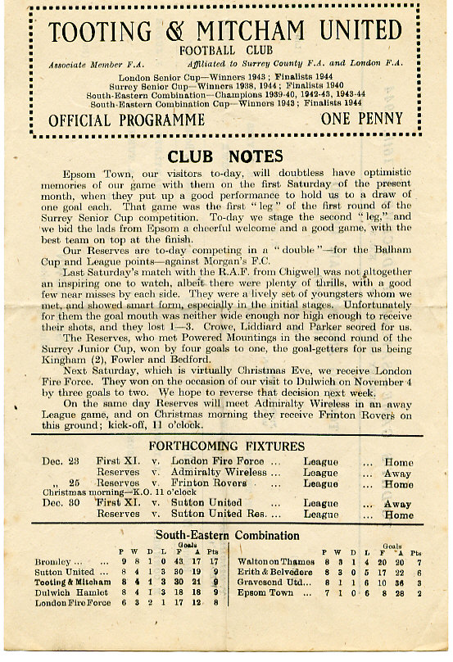
80 years ago today another legend made his debut as Jackie Pullen joined us from Tooting & Mitcham United and scored on his debut. He would go on to join our elite one hundred goals club, one that to this day only contains eight members as we defeated Fulham Reserves in a friendly match by three goals to one at West Street.

70 years ago today the wartime Epsom Town played the second leg of their Surrey Senior Cup tie at Sandy Lane against holders Tooting & Mitcham United. Although Gordon Brogdale scored again, as he had in the first leg, the home side won 4-1 to progress although it must be said that keeper Harry Brown had dislocated his wrist when making a save but just strapped it up and continued playing. Ouch!
(see programme right)

20 years ago this week we played a home game further away than we had ever done when we played Flackwell Heath at Chalfont St Peter. As you do!!

This match was totally memorable for a piece of magic from our new striker Stuart Miller who scored a superb overhead kick in our 3-1 win.

Centre page for results

Centre page for results

EL Records Premier Challenge Cup
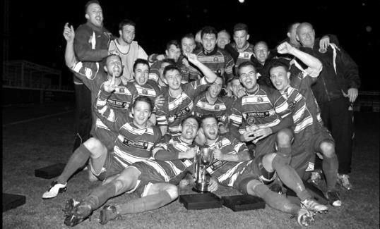
Second Round
Alton Town | 13/12 | Farnham Town
Ashford Town (Mx) | 5-0 | CB Hounslow United
Badshot Lea | 10-2 | Dorking
Bedfont Sports | 1-1+ | Cove
Cove won 4-1 on penalties
Camberley Town | 0-0+ | Molesey
Camberley Town won 3-0 on penalties
Chertsey Town | 0-7 | Windsor
Cobham | w/o Horley | Horley Town
Colliers Wood United | 3-0 | Bedfont & Feltham
Epsom & Ewell | 2-1 | Knaphill
Epsom Athletic | 0-5 | Banstead Athletic
Eversley & California | 2-4 | Ash United
Frimley Green | 1-0+ | Spelthorne Sports
Hanworth Villa | 2-3 | Guildford City
Sheerwater | 1-6 | Mole Valley SCR
Westfield | 4-0 | Farleigh Rovers
Worcester Park | 1-0 | Chessington & Hook United
Third Round
Westfield | 16/12 | Cove
Badshot Lea | 16/12 | Guildford City
Worcester Park | V | Banstead Athletic
Alton Town / Farnham Town | V | Mole Valley SCR
Frimley Green | 0-5 | Epsom & Ewell
Windsor | 2/12 | Ash United
Colliers Wood United | 17/12 | Horley Town
Camberley Town | 3-0 | Ashford Town (Mx)

Surrey Senior Cup
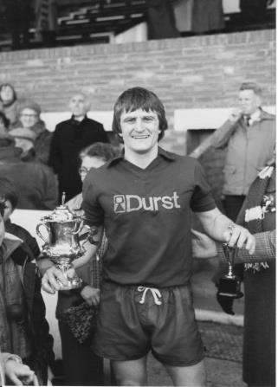

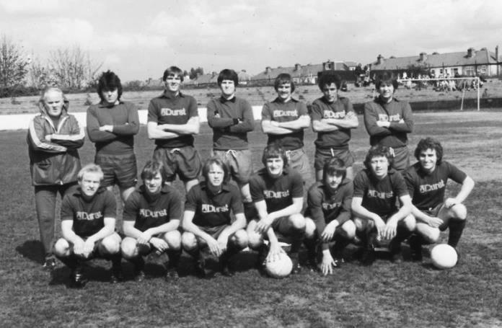
Second Round
Lingfield | 0-1 | Westfield
Redhill | 2-1 | Raynes Park Vale
Played at Raynes Park Vale
AFC Wimbledon | V | Chipstead
Godalming Town | 2-4 | Mole Valley SCR
Knaphill | 0-3 | Colliers Wood United
Metropolitan Police | 1-0 | Walton & Hersham
Epsom & Ewell | 1-0 | Camberley Town
Leatherhead | 2-1 | Farnham Town
Merstham | 3-1 | Beckenham Town
Molesey | 1-0+ | Egham Town
South Park | 1-4 | Sutton United
Walton Casuals | 1-2 | Corinthian Casuals
Badshot Lea | 2-1 | Kingstonian
Dorking Wanderers | 9-0 | Frimley Green
Tooting & Mitcham United | 2-2+ | Horley Town
Tooting & Mitcham United won 4-2 on penalties
Woking | 0-3 | Ashford Town (Mx)
Third Round
Merstham | V | Sutton United
Redhill | V | Westfield
Dorking Wanderers | 7/1 | Colliers Wood United
Molesey | V | Epsom & Ewell
Leatherhead | V | Ashford Town (Mx)
Metropolitan Police | V | AFC Wimbledon / Chipstead
Tooting & Mitcham United | V | Mole Valley SCR
Corinthian Casuals | V | Badshot Lea

Match and Ball Sponsorships – 2014/15
Opponent | Date | Match Sponsor | Ball Sponsor
Raynes Park Vale | 05/08/14 | Club President - Stella Lamont
Horley Town | 25/08/14 | EEFC Management Committee
Croydon (FAC) | 30/08/14 | EEFC Media Officer - Richard Lambert
Frimley Green | 13/09/14 | Dave Gaffney and friends
Guildford City | 30/09/14 | The Jarman family
Mole Valley SCR | 07/10/14 | Mark and Carmel Murphy
Bedfont Sports | 11/10/14 | Epsom & Ewell F.C. Colts
Knaphill (LC) | 14/10/14 | Geoff and Steve Dyke
Ashford Town (Mx) | 18/10/14 | The Building Shop, Bookham
Chertsey Town | 28/10/14 | In Memory of Bob Bexley
Molesey | 22/11/14 | The Cabling Crew 0208 -224 4110
Camberley Town (SSC) | 02/12/14 | In memory of Liz and Doug Burns
Spelthorne Sports | 16/12/14 | Paul Merritt - long serving supporter
Windsor | 03/01/15
Hanworth Villa | 13/01/15
Farnham Town | 17/01/15
Westfield | 31/01/15
Camberley Town | 07/02/15
Hartley Wintney | 21/02/15
Cove | 07/03/15
Badshot Lea | 21/03/15
Colliers Wood United | 04/04/15
Knaphill | 18/04/15
For League, League Cup and Surrey Senior Cup Matches:

Match sponsorship - £40.00 Match ball sponsorship - £25.00.
Combined Offer of Match and Match Ball sponsorship for £55.00.

For F.A. Cup and F.A. Vase matches:

Match sponsorship - £50.00 Match ball sponsorship - £30.00.
Combined Offer of Match and Match Ball sponsorship for £65.00.
----------------------------------------------------------------------------------------------------------------------------
Sponsorship includes

Admission, programmes, advertising (if required) and hospitality.

If you are interested, just speak to a Committee Member, you know where we are!
Alternatively, drop me an email at: richard.c.lambert@gmail.com

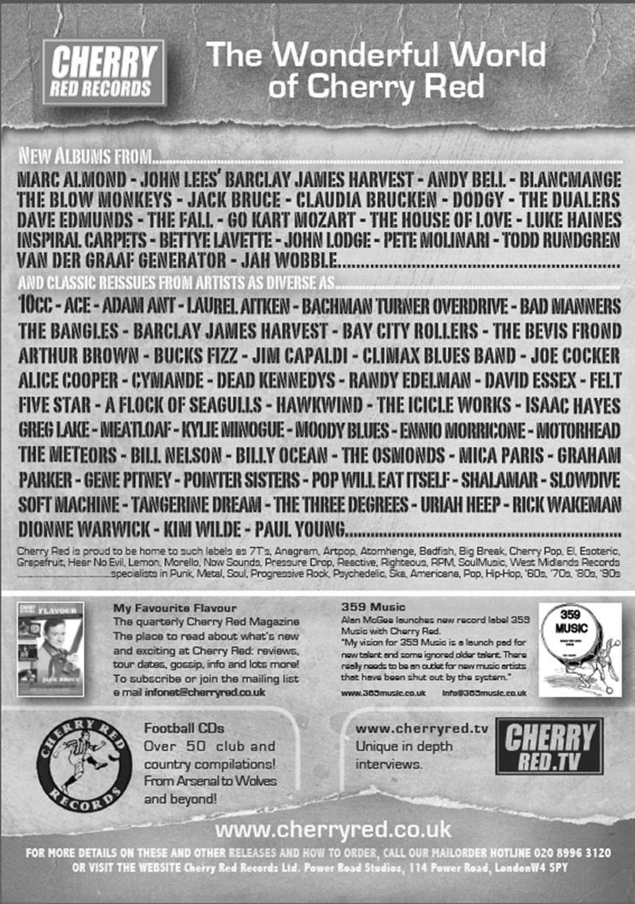

Player Sponsorship
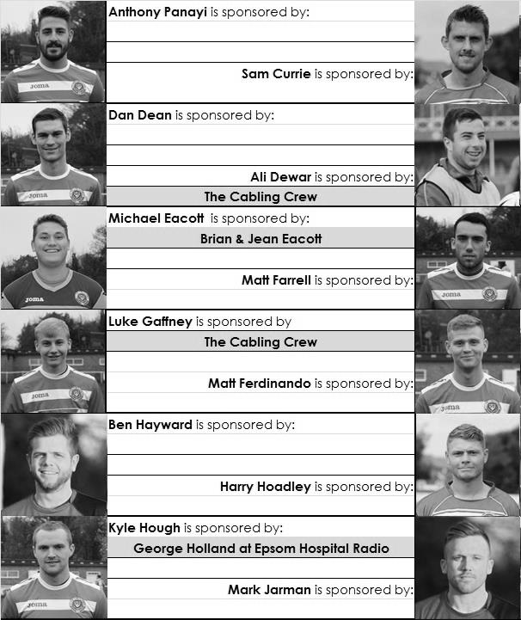

Here is the latest list showing all of the players and Management available for sponsorship. Sponsorship costs £40 so if you want to help the club, the player and get your name in the programme for the season, just let us know before they go!

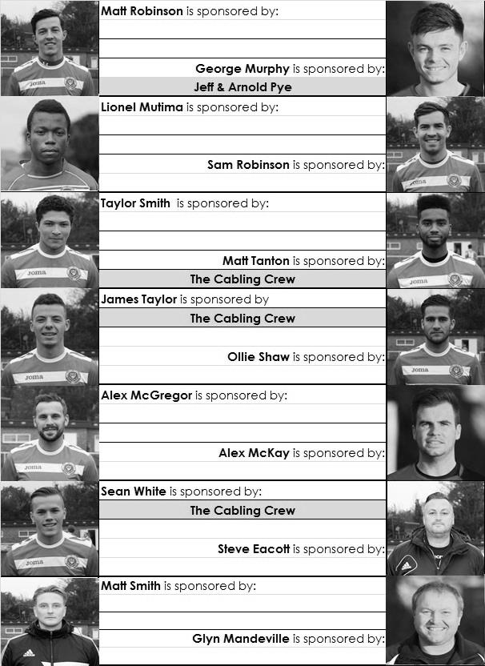

From behind the goal
Frimley Green 0-5 Epsom & Ewell
Combined Counties League Cup - Third Round - Tuesday 9th December 2014

Salts stroll into quarter finals for third year in a row

The Salts cruised into the Quarter Finals of the League Cup with probably their easiest win of the season at the Frimley Recreation Ground. Despite missing the suspended Sam Robinson and Matt Farrell, a good early start shattered the fragile confidence of the hosts leading to a very comfortable victory.

Against a team with six straight League defeats to their name it was important to get off to a great start and that's exactly what happened. With the clock just into the 7th minute Matt Robinson flicked a header on to Matt Ferdinando on the right and he hit a low drive from just inside the box into the bottom corner that gave Jamie Cunningham in the Frimley goal no chance. Cunningham had performed heroics in our goalless League match back in September, but despite playing well again, he would have no clean sheet this evening. Six minutes later Ferdinando turned provider as he fed Kyle Hough from the right hand side. From about ten yards out and despite the presence of nearby defenders he coolly transferred the ball to his left foot and curled the ball into the same corner as our previous goal. In the 16th minute, Robinson should have made it three when Hough set him up with just the keeper to beat but his shot was blocked from close range for a corner, from which George Murphy sent a powerful header goalwards but Cunningham at full stretch kept him out.

There was a sign of troubles to come when Matt Robinson and Andrew Grace got tangled up and decided to keep the argument going. The referee gave both a lecture but as they walked away, they continued to "discuss" the incident. Grace pushed his head forward and Robinson reacted. Unfortunately for him the referee only witnessed the retaliation and a yellow card followed. It left him on a tightrope for the remainder of the game. We just needed to concentrate on the football as opposed to the extra-curricular activities and from the original free kick that Robinson had earned, Alex McGregor curled the ball into the danger area and James Taylor, playing in a more advanced right back position, reached the ball ahead of the advancing keeper and defender and flicked it over them into the empty net. Twenty-one minutes in and the game was over!

Frimley had created nothing by this point and their only attempt of note in the first half came on the half hour mark when a decent free kick was allowed to bounce in our area and out for a goal kick. However, within two minutes this was forgotten as Robinson sent Ferdinando through on the left and he reached the ball ahead of Cunningham with his touch just having enough on it to get the ball over the line before a defender could arrive.

The unlucky Robinson missed another good chance when Taylor's superb right wing cross was on a plate for him to volley in, but he got it all wrong and the ball dribbled wide from just six yards out. It didn't seem to affect him though as he kept making good chances for his team mates and a right wing cross was volleyed inched wide of the far post by Alex McKay in the 42nd minute.

In the second half we looked in the mood for more goals with McGregor having a free kick pushed away by Cunningham and a defender clearing a loose ball off the line just in front of Taylor. On the hour mark we got our fifth of the night. Ferdinando had his shot well blocked by the keeper as was Hough's follow up, but the ball came back to him and he knocked it into the corner for his second left footed goal of the night.

Unfortunately we got involved in a rather nasty incident in the 67th minute. Ferdinando put in a very strong but legal challenge and the reactions that followed led to almost everyone on the pitch joining in a rather nasty punch up! Our man defended himself but was also guilty of throwing punches and received a red card, while after consultation with his Assistants, the referee then sent Andrew Newcombe and Dale Webb off for the home team. Their keeper, who of course was stood near me, believed that the referee got one of those players wrong, but he seemed to have no problem with two players going. To be honest it was difficult to see much from our distance as all the players converged on each other.

Glyn Mandeville quickly substituted Robinson as he had continued his earlier argument with his opponent and clearly didn't want to risk any more suspensions in a game that was over as a contest by that point. This gave Sam Currie the opportunity to get some playing time after his nasty injury back in August and once he is match fit he will strengthen Glyn's selection options further. Regrettably Dan Dean picked up his fifth booking of the season for a debateable foul nine minutes from time and we played the remainder of the game by keeping the ball "at arm's length" from our hosts, leading to a very quiet finish. You wouldn't believe that at the start of the game the teams had posed for a Football Together picture!

Team: Michael Eacott, James Taylor, Matt Tanton Anthony Panayi ©, George Murphy, Alex McKay, Dan Dean, Matt Ferdinando, Kyle Hough, Alex McGregor, Matt Robinson. Sub: Sam Currie for Robinson (73)

Salts Super Six Predictor
The Salts Super Six Predictor is live again and the deadline is Saturday 20th December. Tickets are on sale at tonight’s game.

The competition is easy to play and you don’t even have to be at the match! To win, you simply need to predict the results of six matches correctly from the three options, fill in the form and make sure it is back with one of our distributors before the deadline on the ticket. The latest fixtures are shown here. We nearly had a winner last week when Sam Currie got five out of six right!

If you are a club regular, you just need to place your name on the sheet, although if you aren’t, then we’ll need a contact number from you too. We will announce any winners on the website within three working days, so don’t worry, we won’t miss you!

The prize pot is currently £100 but will continue to go up, if unclaimed, by the cost of 50% of all the sold tickets. In other words, if we sell 100 tickets at £2 before the deadline, and the pot isn’t won, then the next prize will be £200! You’ll always know the size of the pot before you enter.

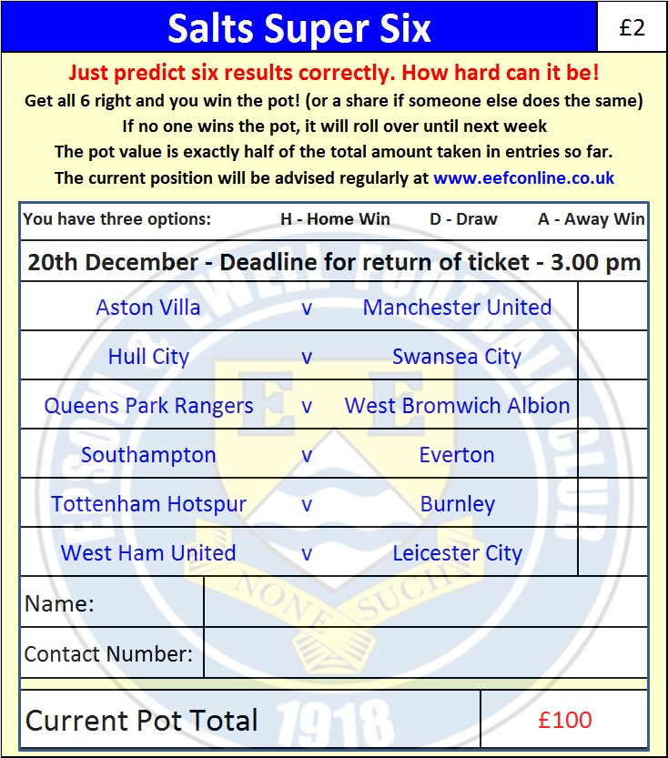
Please note that if there is more than one winner, the prize pot would be shared between the winners. All you need to do now is have a go, as many times as you like!

Good luck!

Combined Counties League – Premier Division
Tuesday, 16th December 2014 - Kick-off 7.45 p.m.
Epsom and Ewell  (Royal Blue & White hoops) | V |  | Spelthorne Sports  (All White)
 | NUMBERS
Michael Eacott |  |  | Gary Phillips
James Taylor |  |  | Josh Remedios
Matt Tanton |  |  | Jamie Richards
Anthony Panayi |  |  | Ciaron Brown
George Murphy |  |  | Jake Flatman
Dan Dean |  |  | Paul Johnson
Matt Ferdinando |  |  | Jake Hicks
Matt Farrell |  |  | Lee Staples
Kyle Hough |  |  | Robert Smith
Alex McGregor |  |  | Tom Hall
Sam Robinson |  |  | Adam Williams
Taylor Smith |  |  | Junior Wright
Matt Robinson |  |  | Jesse Ataise
Alex McKay |  |  | Jordon Wain
Luke Gaffney |  |  | James Stenning
Ollie Shaw |  |  | Ben Buzzard
Sam Currie |  |  | Simo Mbonkwi
Ali Dewar |  |  | Franky Law
Steve Rowe |  |  | David Green
Ben Hayward |  |  | Kai Franices
Glyn Mandeville | MANAGER |  | Paul Johnson
Matt Smith | ASSISTANT |  | Gary Ross
Steve Eacott / Alex McKay | COACHES
Ken Jones | PHYSIO |  | Elliot Ataise
REFEREE: A.Lewis (Tooting)
ASSISTANTS: R.Van Niekerk (Sutton), B.Gale (North Cheam)
Today’s Match and Match Ball are sponsored
By long serving supporter Paul Merritt

OUR NEXT VISITORS TO HIGH ROAD
Windsor
Saturday 3rd January 2015 - Kick-off 3.00 p.m.
Combined Counties League – Premier Division

